naturalLiving
your home. your world.

2020 Spring Subscription Form
“Natural Gas: Good for the Planet, Good for Your Wallet” | - Energy Star Appliances  - Natural gas is the eco-friendly choice according to the NIST study  - The benefits of natural gas water heating  - Want to save more? Go tankless!  - Creating an outdoor kitchen  - Natural Gas: The right choice  - Time for spring cleaning!

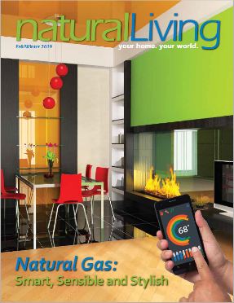  naturalLiving  your home. your world |  | # Hard Copies | Price | Total
 |  |  | $.90 each ( < 5,000 Subscriptions)  - OR -  $.80 each ( > 5,000 Subscriptions) | $
 |  | Electronic Flip Book | $425.00 | $
 |  | Add your B&W Logo to hard copies  Add your color logo to hard copies  Check here for a free  branded pdf | $425.00  $1275.00  $0 | $  $
 |  | Total  Hard copies expected to ship January21st |  | $
BILLING | Name:  Company:  Phone:  Email: |  | Address:  City:  State / Zip:
SHIPPING | Name:  Company:  Phone: |  | Address:  City:  State / Zip:  Copies to send to this address:
Provide additional shipping addresses on a separate sheet. Include the amount to ship to each site.
Email form to bstinson@escenter.org by December 2, 2019

All orders will be invoiced; a credit card may be used once the invoice is received

